BLACKROTH PROJECT
JIRA TASK 02 — Database Indexing, Query Optimization & Performance
EPIC 06 — Database & Distributed Data Design

Document field | Value
Project | BlackRoth Project
Epic | EPIC 06 — Database & Distributed Data Design
Completion date | 29-Sep-2026
Status | Completed • On Time • Not Overdue
Prepared for | JIRA task completion record

Evidence-based final documentation

1. Task Status and JIRA Scope
Item | Record
JIRA task | Task 02 — Database Indexing, Query Optimization & Performance
Task date shown on JIRA | 29-Sep-2026
Effort | 8 Hours
Priority | High
Completion date | 29-Sep-2026
Completion status | Completed
On time | Yes
Overdue | No
Objective | Identify slow database operations and improve query performance through indexes, query plans, pagination, and optimization practices.

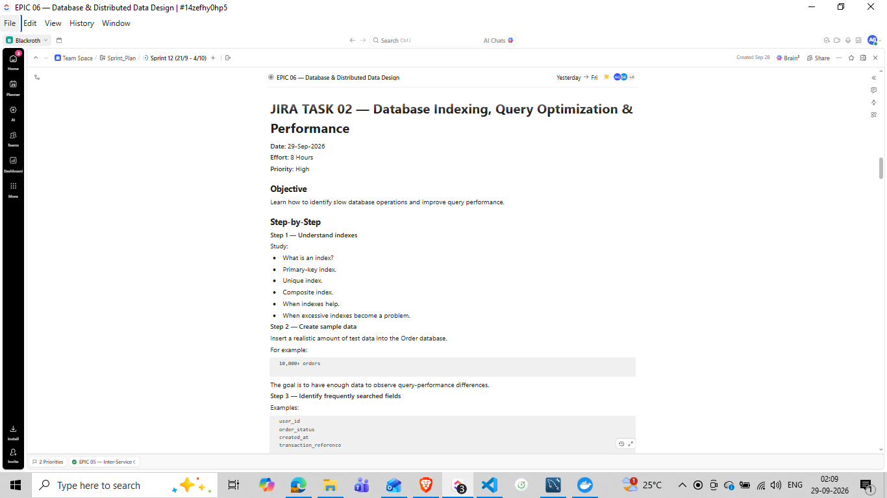
Figure 1 — JIRA Task 02 card showing the task scope, 10,000-order sample data, indexing steps, query optimization topics, performance report, and deliverables.

2. Starting Dataset
Before the performance work, the Order Service orders table contained 13 records. A synthetic dataset of 9,987 additional orders was inserted, bringing the total to exactly 10,000 orders. The generated records varied user_id, product_name, quantity, amount, status, created_at, and updated_at so that query-plan behavior could be observed on a larger table.
SELECT COUNT(*) AS total_orders
FROM orders;
Result: 10000
Dataset result
Exactly 10,000 orders were present before the baseline query-plan measurements were taken.

3. Index Understanding Applied to the Orders Table
An index is an additional database structure that helps the database locate matching rows efficiently. The task work used the primary-key index already present on id, then added a single-column index for user_id and a composite index for user_id + created_at. The composite index matches the query pattern that filters by user and sorts by creation time.
Index type | Meaning in this task
Primary-key index | Existing PRIMARY index on orders.id for direct row lookup.
Single-column index | user_id_index on orders.user_id for frequent user-based filtering.
Composite index | user_created_index on orders(user_id, created_at) for user filtering plus creation-time ordering.
Excessive indexes | Not added indiscriminately; indexes were limited to the query patterns demonstrated in the task.

4. Baseline — Query Before Adding a User ID Index
The frequently searched test query was:
EXPLAIN
SELECT *
FROM orders
WHERE user_id = 1;
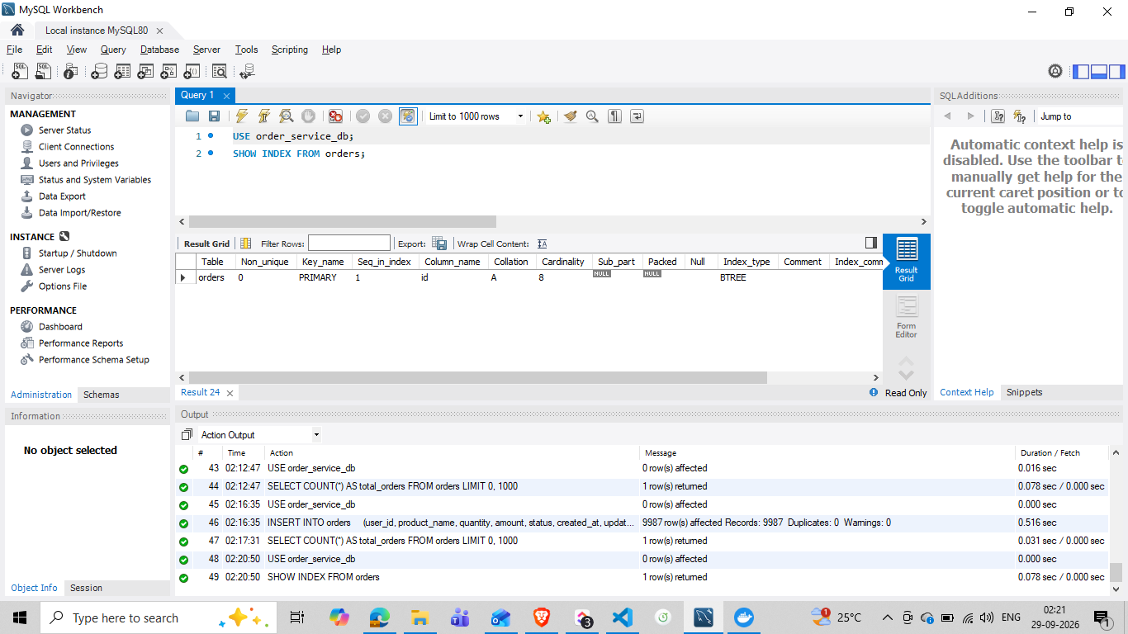
Figure 2 — SHOW INDEX FROM orders before the new index was added; only the PRIMARY index on id was present.
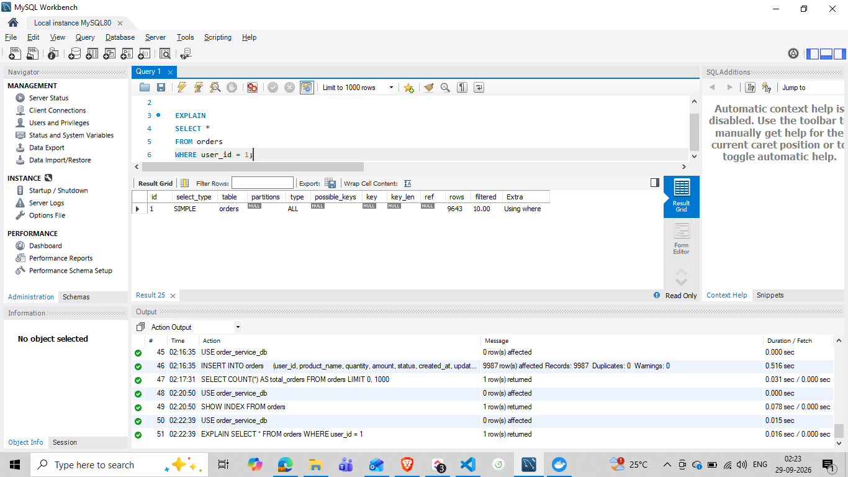
Figure 3 — Baseline EXPLAIN for user_id filtering; type ALL, key NULL, estimated rows 9643.
Before index metric | Observed value
type | ALL
possible_keys | NULL
key | NULL
rows | 9643
Extra | Using where

Baseline interpretation
MySQL had no user_id index available for the query and therefore planned a broad scan of the orders table. The 9643 value is an optimizer estimate, not a direct wall-clock timing measurement.

5. Single-Column Index on user_id
A simple index name was used for clarity: user_id_index.
CREATE INDEX user_id_index
ON orders(user_id);
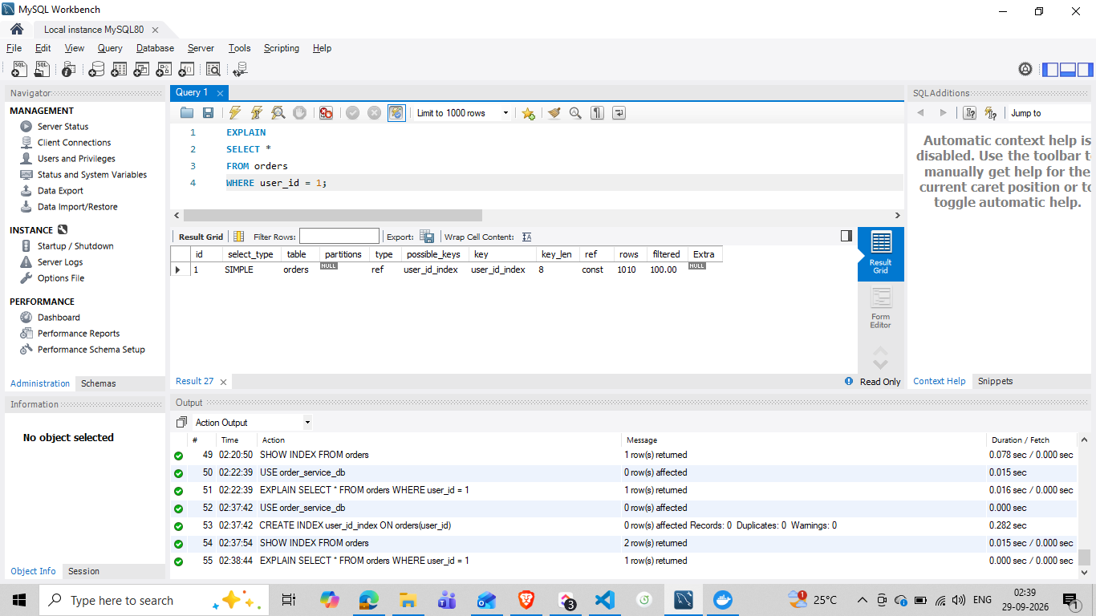
Figure 4 — EXPLAIN after adding user_id_index; MySQL uses the new index with type ref and an estimated 1010 rows.
Metric | Before | After
type | ALL | ref
key | NULL | user_id_index
estimated rows | 9643 | 1010
filtered | 10.00 | 100.00
Plan interpretation | Broad scan | Indexed lookup

The optimizer estimate decreased from 9,643 rows to 1,010 rows, a reduction of about 89.5% in the estimated rows examined for this filter. This is a plan-level improvement; no before/after wall-clock benchmark was captured for this exact query.

6. Composite Index on user_id + created_at
The task then used a query that both filters by user and sorts by creation time descending:
SELECT *
FROM orders
WHERE user_id = 1
ORDER BY created_at DESC;
CREATE INDEX user_created_index
ON orders(user_id, created_at);
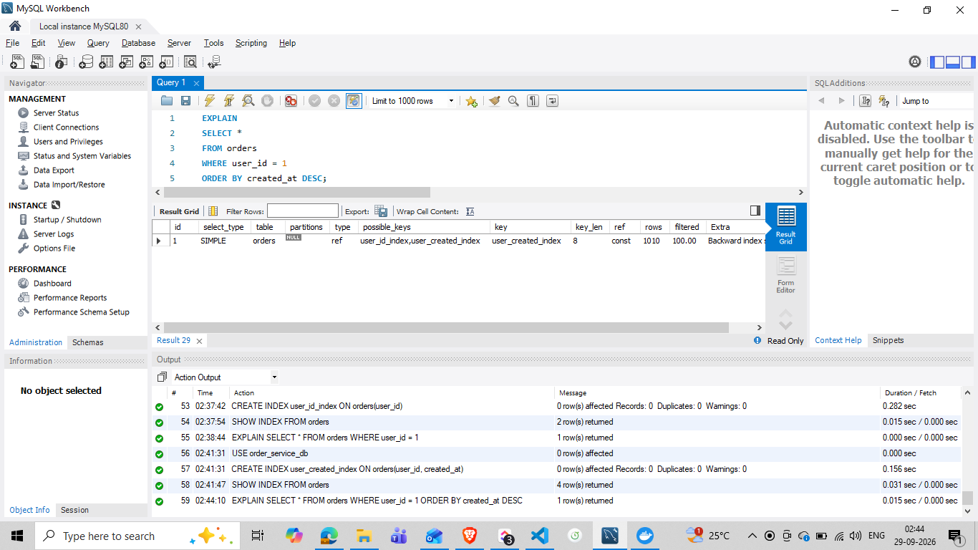
Figure 5 — EXPLAIN for the composite-index query; MySQL selects user_created_index and reports a Backward index scan.
Composite-index metric | Observed value
possible_keys | user_id_index, user_created_index
key | user_created_index
estimated rows | 1010
Extra | Backward index scan

Column order matters because the index begins with user_id, which matches the equality filter. The created_at column follows it, allowing the index order to support the requested newest-first traversal for the matching user set.

7. Avoiding SELECT *
The same query pattern was rewritten to return only the columns needed by the application:
EXPLAIN
SELECT id, user_id, amount, status, created_at
FROM orders
WHERE user_id = 1
ORDER BY created_at DESC;
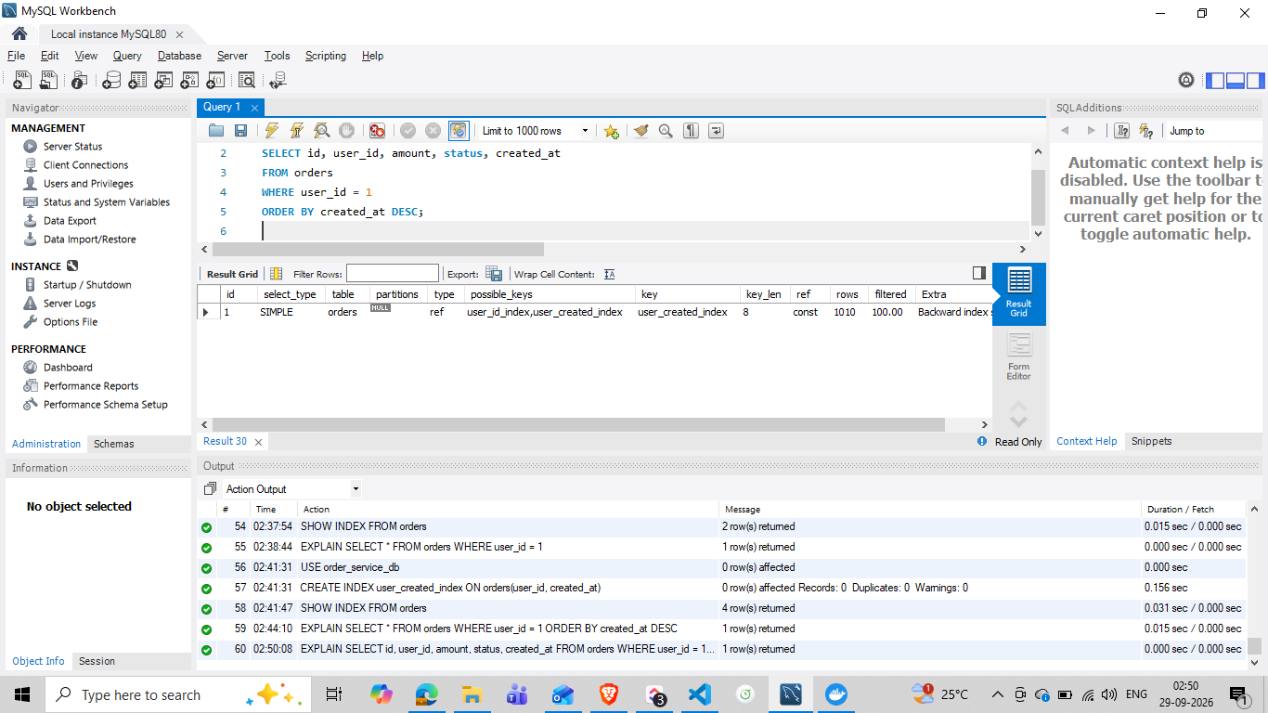
Figure 6 — EXPLAIN for the reduced-column query; MySQL continues using user_created_index and the backward index scan.
Optimization principle
Selecting only required columns reduces unnecessary result data compared with SELECT *. In this test, the optimizer continued to use the same composite index plan.

8. Pagination with LIMIT and OFFSET
Pagination was demonstrated using 10 records per page. LIMIT controls how many rows are returned, while OFFSET controls how many matching rows are skipped before the returned page begins.
Page 1
SELECT id, user_id, amount, status, created_at
FROM orders
WHERE user_id = 1
ORDER BY created_at DESC
LIMIT 10 OFFSET 0;
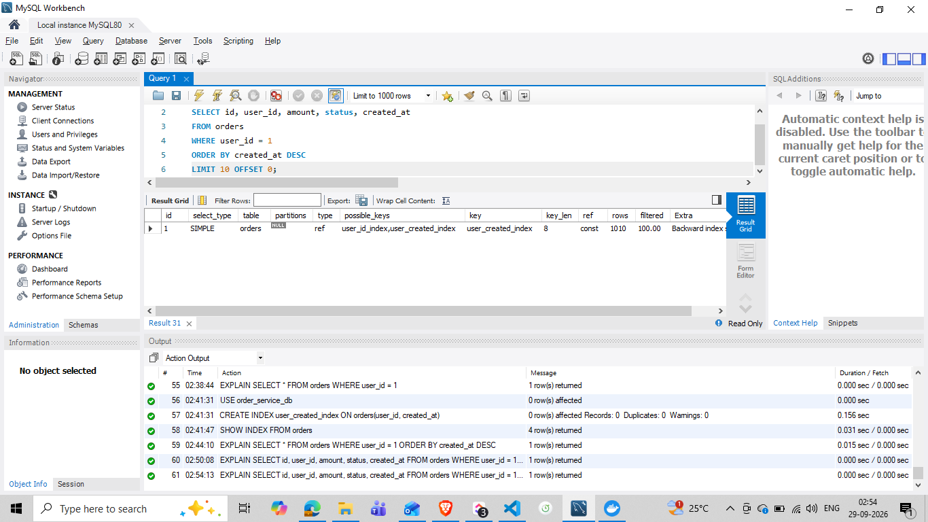
Figure 7 — Page 1 query returning 10 actual order records.
Page 2
SELECT id, user_id, amount, status, created_at
FROM orders
WHERE user_id = 1
ORDER BY created_at DESC
LIMIT 10 OFFSET 10;
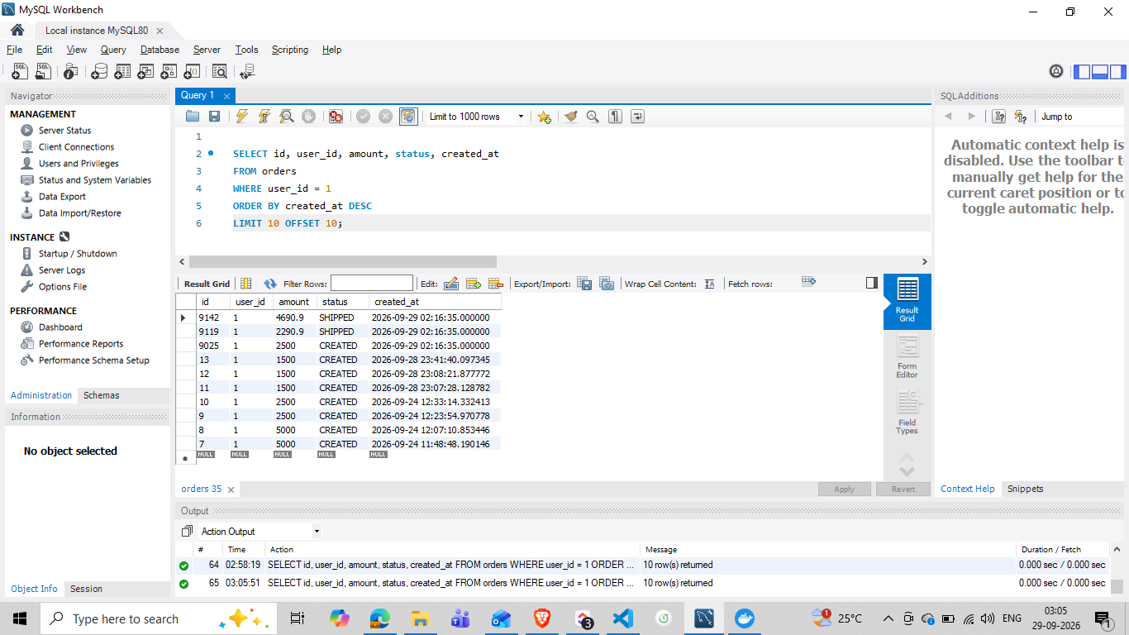
Figure 8 — Page 2 query returning the next 10 actual order records.

Page | LIMIT | OFFSET | Meaning
1 | 10 | 0 | Return records 1–10 of the filtered, sorted result set.
2 | 10 | 10 | Skip the first 10 and return the next 10.

9. EXPLAIN ANALYZE — Actual Execution Evidence
The optimized paginated query was executed with EXPLAIN ANALYZE to capture actual execution information:
EXPLAIN ANALYZE
SELECT id, user_id, amount, status, created_at
FROM orders
WHERE user_id = 1
ORDER BY created_at DESC
LIMIT 10 OFFSET 10;
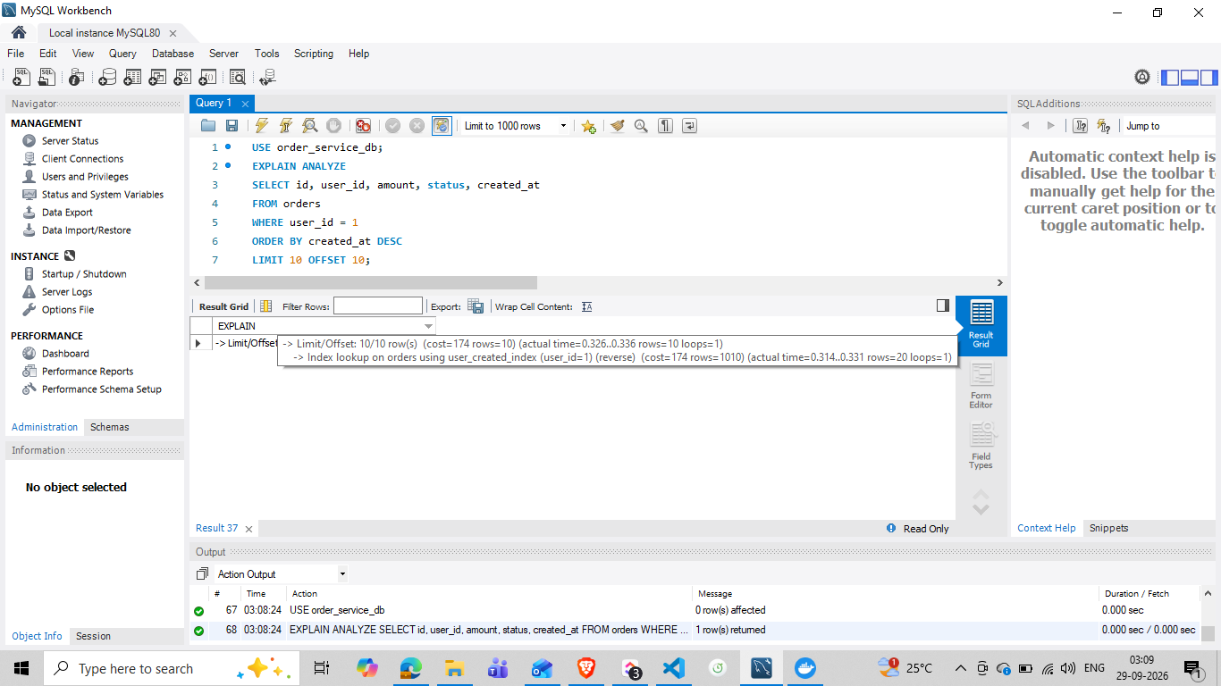
Figure 9 — EXPLAIN ANALYZE evidence showing index lookup using user_created_index and Limit/Offset execution.
Execution detail | Observed value
Index lookup | orders using user_created_index (reverse traversal)
Actual index lookup time | approximately 0.314–0.331
Rows read for page 2 | 20
Limit/Offset output | 10 rows
Loops | 1

The plan reads approximately 20 matching rows for page 2 because OFFSET 10 skips the first 10 and LIMIT 10 returns the next 10. The actual timing values shown above are the execution measurements reported by EXPLAIN ANALYZE in the work session.

10. Performance Comparison Report
Scenario | Plan / result | Performance evidence
Before user_id index | Full table scan; key NULL; estimated rows 9643 | Baseline EXPLAIN
After user_id_index | Indexed lookup; key user_id_index; estimated rows 1010 | Post-index EXPLAIN
After user_created_index | Composite-index lookup; key user_created_index; estimated rows 1010; backward scan | Composite EXPLAIN
Reduced-column query | Same composite index plan while selecting only required columns | Optimized EXPLAIN
Paginated page 1 | 10 actual records returned | SELECT verification
Paginated page 2 | 10 actual records returned after offset 10 | SELECT verification
Paginated EXPLAIN ANALYZE | 20 rows processed for page 2; 10 returned; actual execution timing captured | EXPLAIN ANALYZE

Measurement note
A direct before/after wall-clock benchmark using EXPLAIN ANALYZE was not captured for the same non-paginated query. The report therefore separates optimizer-plan evidence (before/after index) from the actual execution trace captured for the optimized paginated query. This avoids overstating the measurement.

11. Updated Database Documentation
The orders table now has the following relevant indexes after this task:
Index name | Columns | Purpose
PRIMARY | id | Primary-key lookup and row identity.
user_id_index | user_id | Frequently filtered user-based queries.
user_created_index | user_id, created_at | User filtering combined with newest-first creation-time ordering.

The task intentionally avoided adding indexes to every searchable field. Indexes were created to match the query patterns demonstrated in the JIRA task, keeping the implementation focused and production-presentable.

12. Query Optimization Practices Demonstrated
Practice | How it was demonstrated
Avoid unnecessary SELECT * | Selected only id, user_id, amount, status, created_at.
Pagination | Used LIMIT 10 with OFFSET 0 and OFFSET 10.
Database-level filtering | Applied WHERE user_id = 1 in SQL.
Indexing | Added user_id_index and user_created_index.
Query-plan inspection | Used EXPLAIN before and after indexes.
Actual execution inspection | Used EXPLAIN ANALYZE on the optimized page-2 query.
Composite-index design | Used (user_id, created_at) for filtering + ordering.

13. Deliverables Checklist
JIRA deliverable | Status | Evidence / location
Sample dataset | Completed | Section 2 — 10,000 orders
Index definitions | Completed | Sections 3, 5, 6, and 11
Query optimization examples | Completed | Sections 7, 8, and 12
Query-plan evidence | Completed | Sections 4, 5, 6, 7, and 9
Performance comparison report | Completed | Section 10
Updated database documentation | Completed | Section 11

14. Final Outcome
JIRA Task 02 was completed on 29-Sep-2026 and recorded as on time with no overdue status. The task established a measurable indexing and query-optimization workflow on a 10,000-row orders dataset: baseline plan capture, user_id indexing, composite-index design, reduced-column queries, pagination, and actual execution-plan analysis with EXPLAIN ANALYZE.

